# **CS 340 README Template**

**About the Project/Project Title**

The project aims to develop a Python dashboard using the Dash framework to visualize and interact with data from the Austin Animal Center (AAC) Outcomes dataset. The dashboard includes interactive options to filter the data, a data table that dynamically responds to the filtering options, and two charts (geolocation chart and a pie chart) that also respond to the filtering options.

## **Getting Started**

1. Clone the project repository from GitHub.
2. Install the required dependencies, including PyMongo and other relevant packages.
3. Set up the MongoDB server and ensure it is running.
4. Import the AAC Outcomes dataset into MongoDB using the provided CSV file and the appropriate MongoDB import tool.
5. Review the project documentation and code examples for further instructions and usage details.

## **Installation**

To run this, you will need to use the following:

* Python 3.x
* PyMongo
* IDE such as Jupyter Notebook
* Terminal/Command Prompt

**Screenshots**

To demonstrate the functionality of the project, I have created the following screenshots:

1. Starting state of the dashboard (Also Reset status):

- The dashboard includes interactive options (radio buttons) to filter the data.

- An interactive data table displays an unfiltered view of the AAC Outcomes dataset.

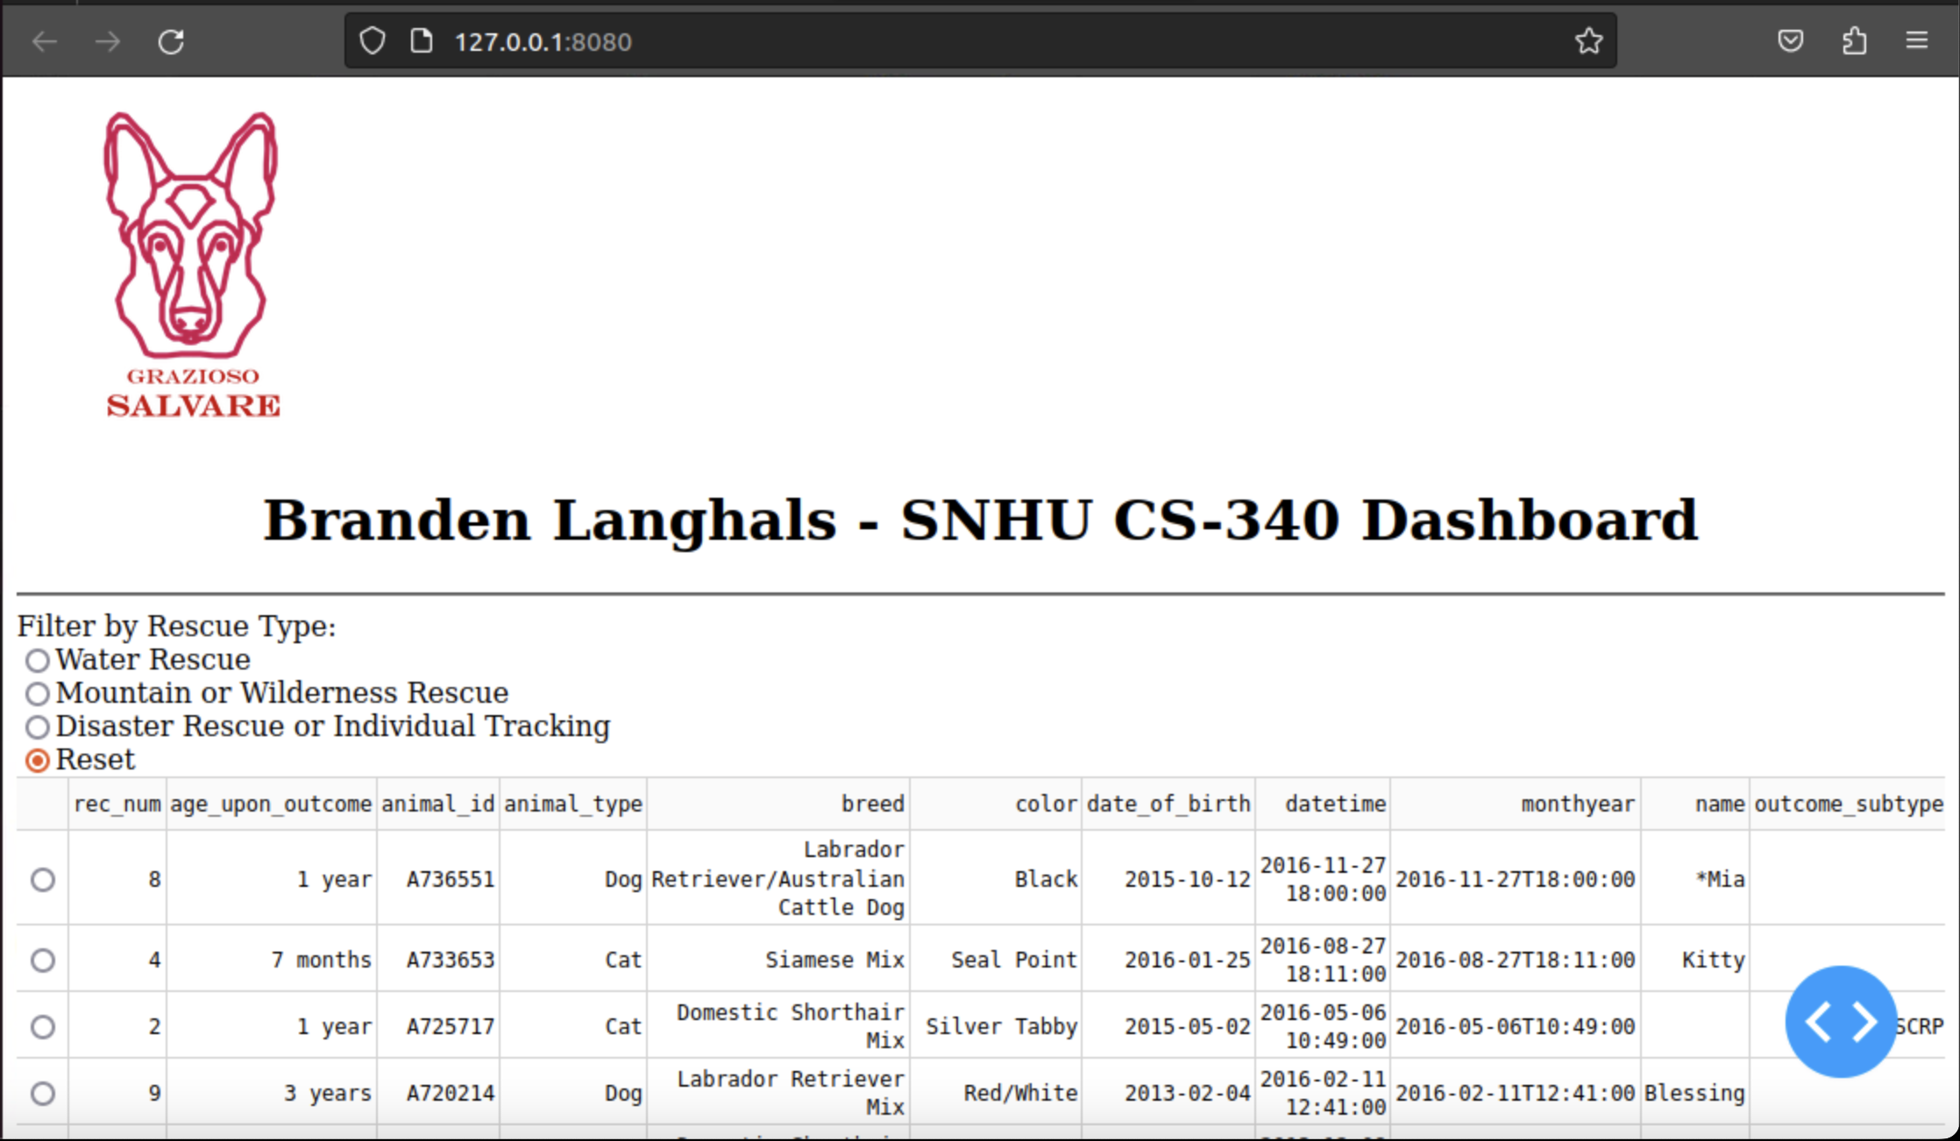

- A geolocation chart and a second chart are also present.

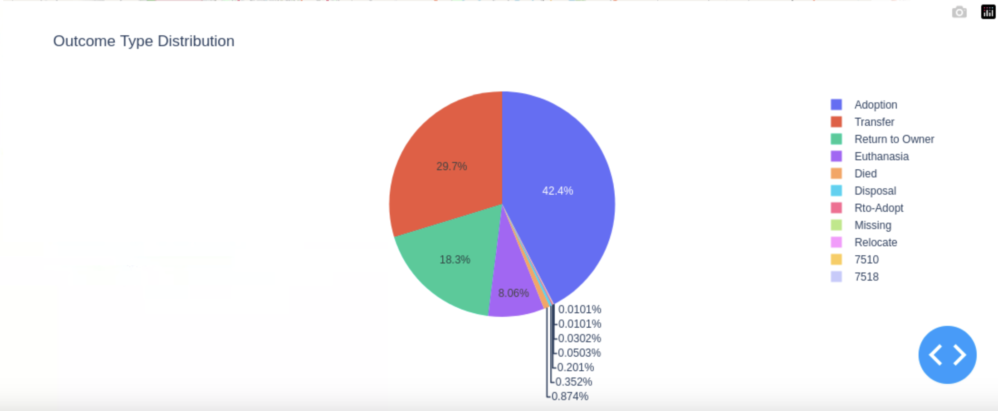

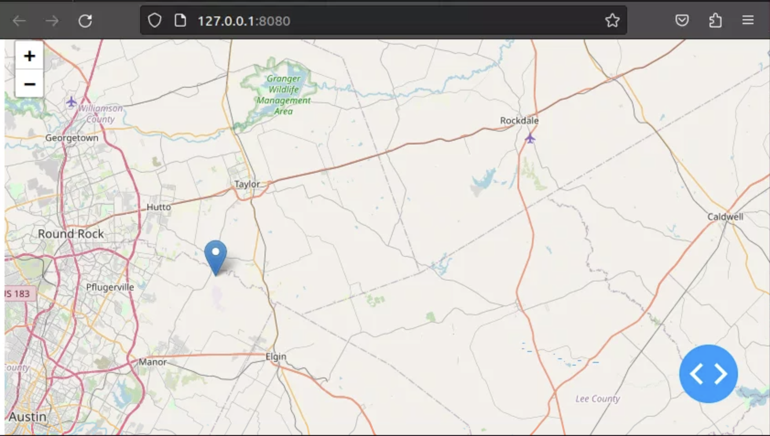

2. Execution after applying the "Water Rescue" filter:

- The data table and charts update to show data related to water rescues.

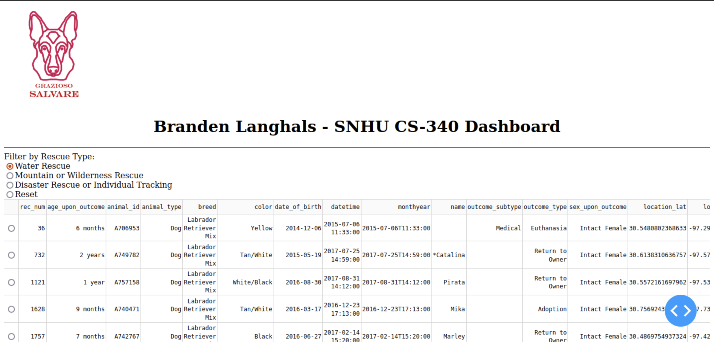

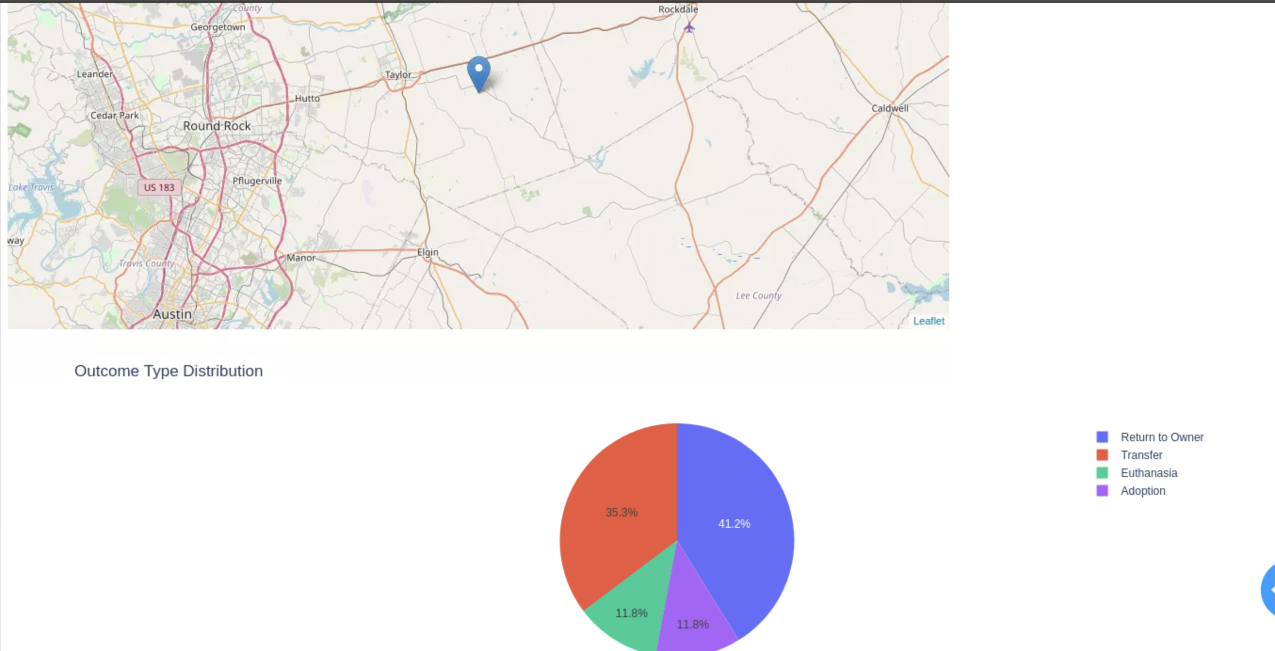

3. Execution after applying the "Mountain or Wilderness Rescue" filter:

- The data table and charts update to show data related to mountain or wilderness rescues.

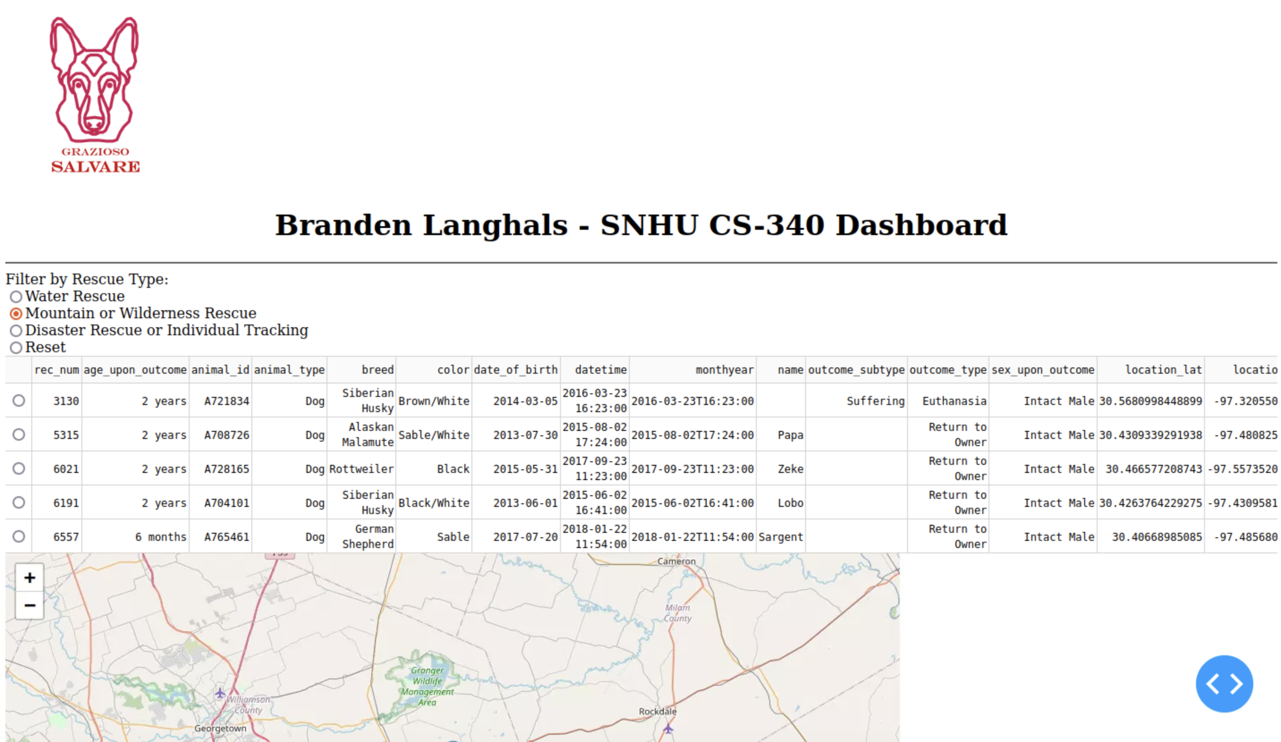

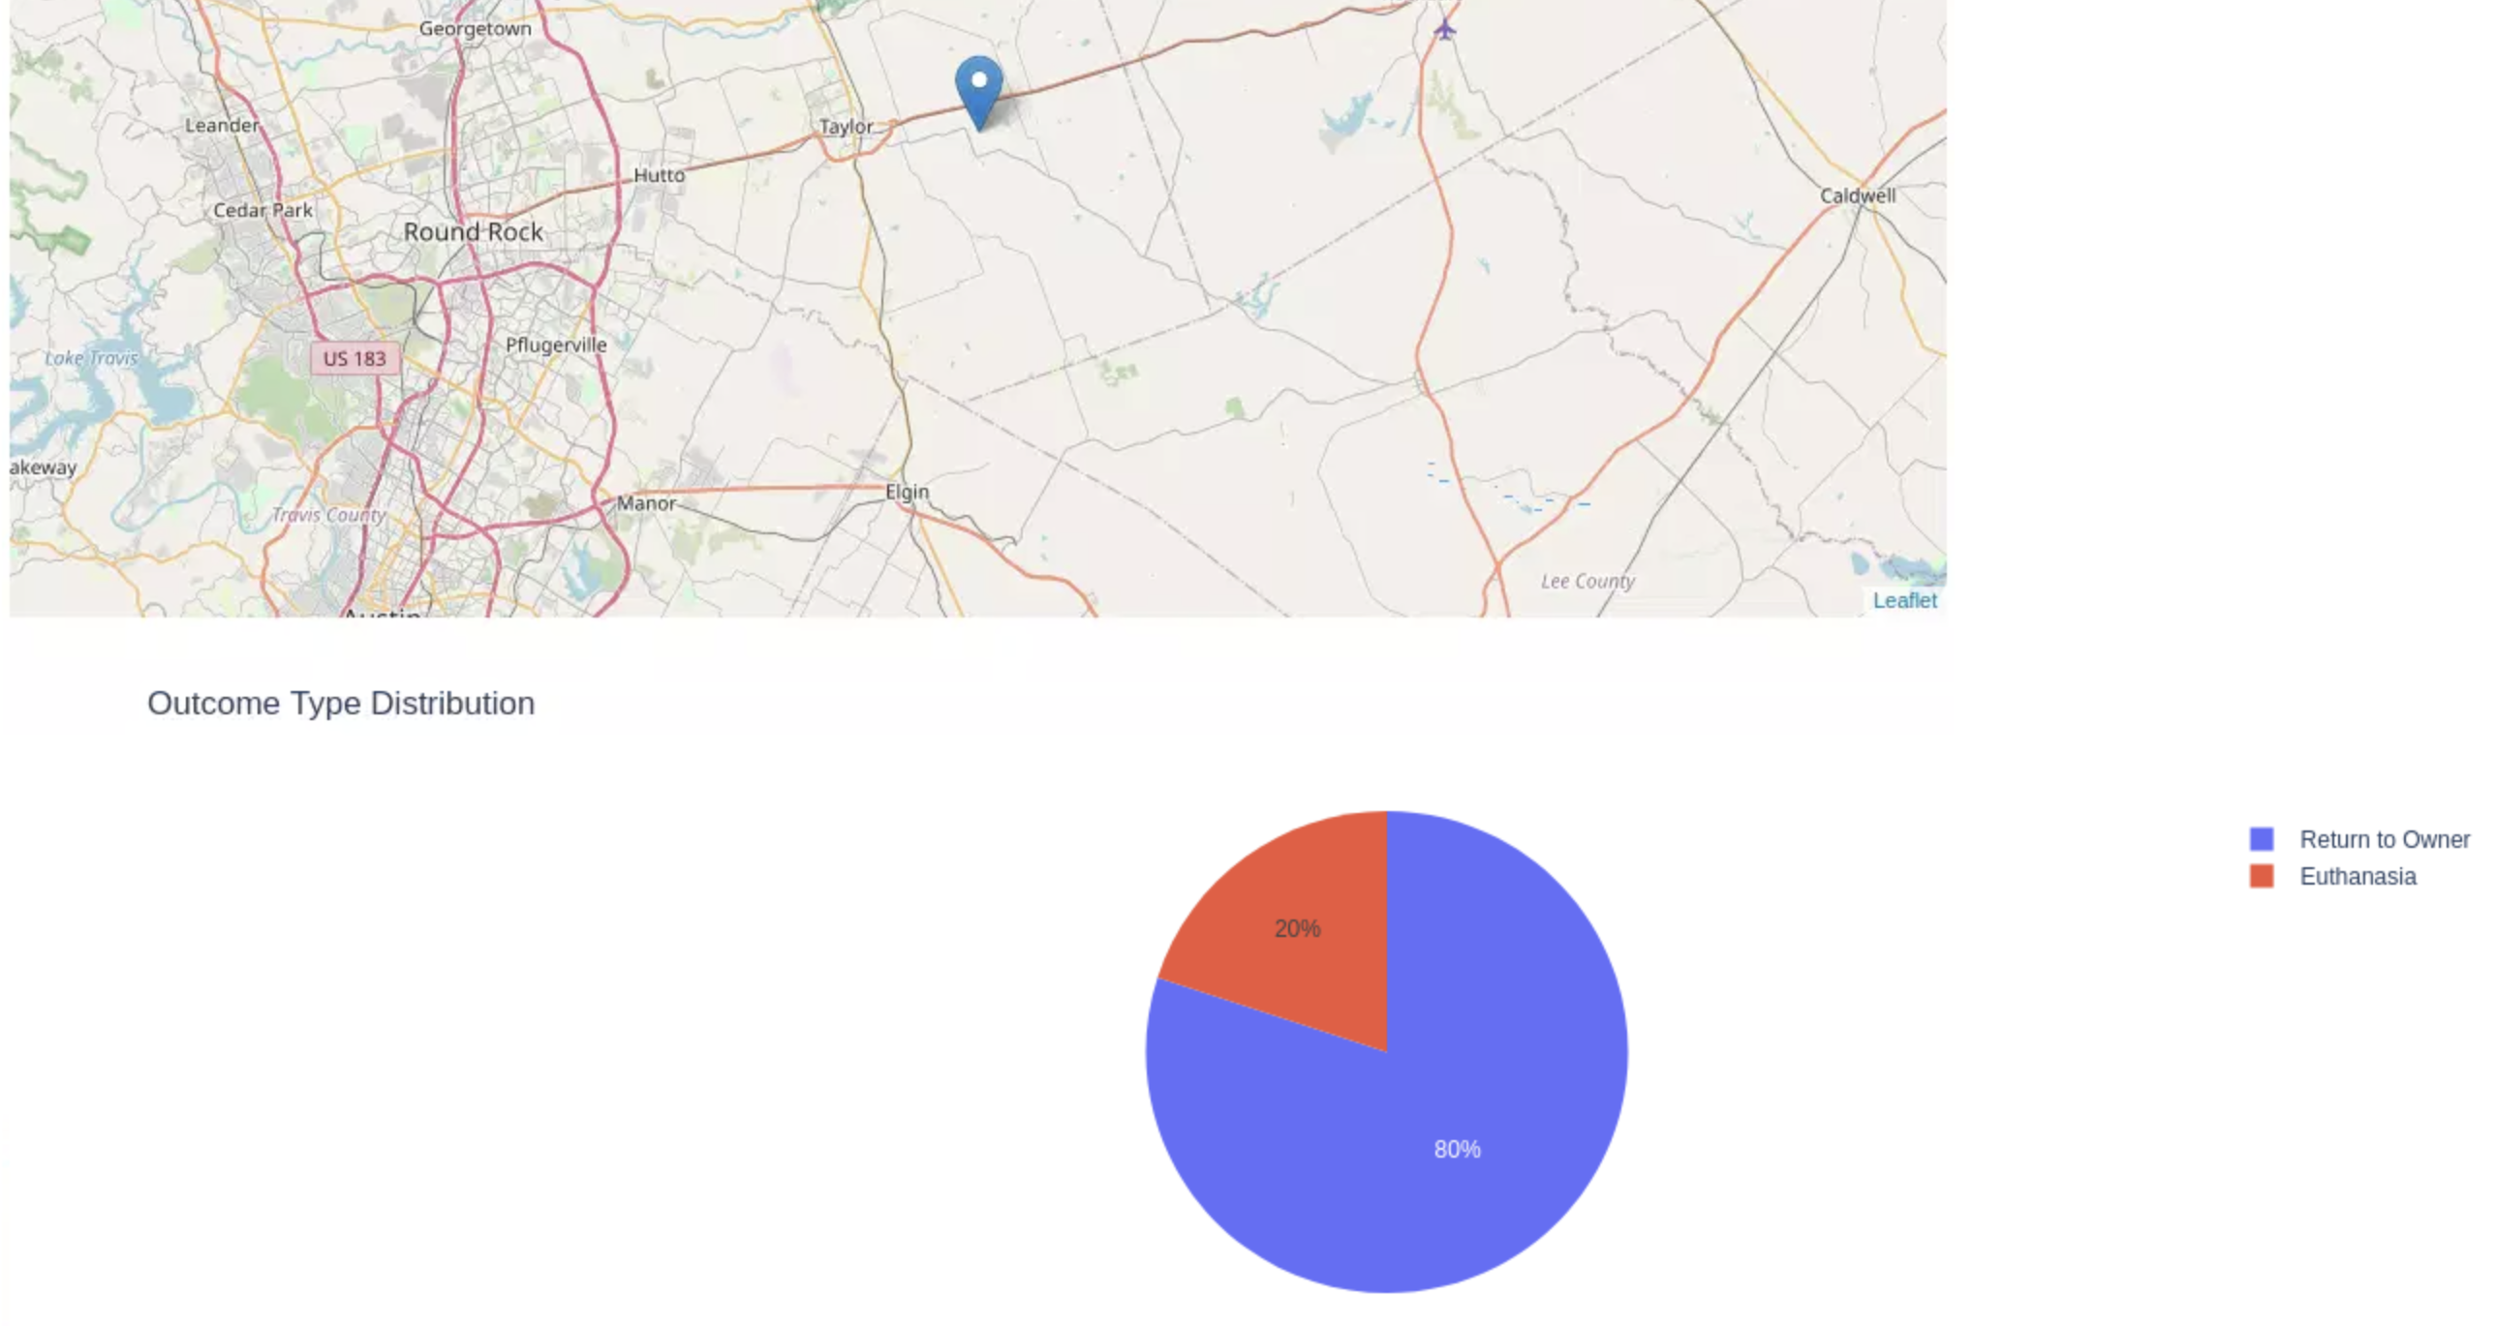

4. Execution after applying the "Disaster or Individual Tracking" filter:

- The data table and charts update to show data related to disaster or individual tracking.

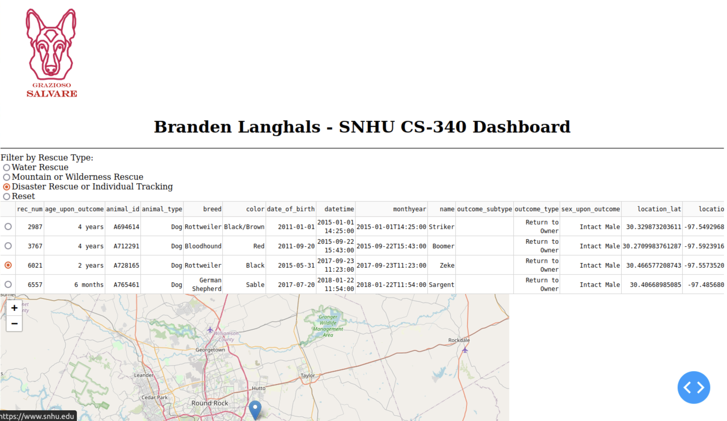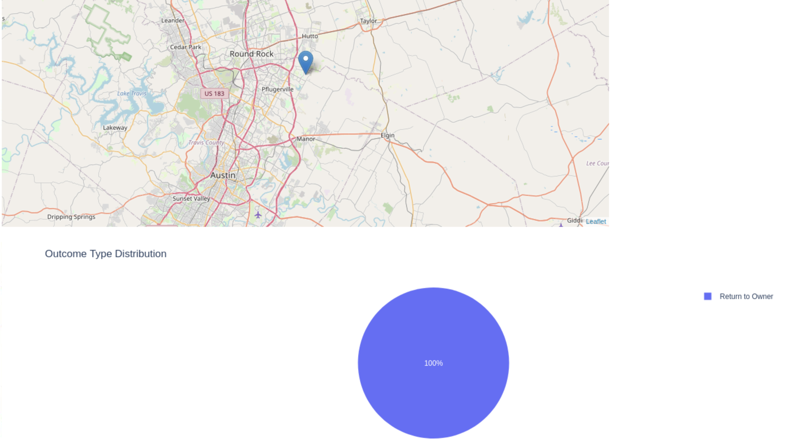

Tools Used

- [Python](https://www.python.org/): The main programming language used for developing the dashboard and interacting with the MongoDB database.

- [Dash](https://plotly.com/dash/): A Python framework used for building web applications and creating interactive dashboards.

- [PyMongo](https://pymongo.readthedocs.io/): A Python library used to interface with the MongoDB database.

- [MongoDB](https://www.mongodb.com/): A NoSQL database used as the model component for storing and retrieving data. It was chosen for its flexibility, scalability, and ability to handle large volumes of data.

These tools were selected for their compatibility, robustness, and suitability for the project requirements. Python provided a versatile and widely used programming language, while Dash offered a straightforward way to create interactive web applications. PyMongo facilitated seamless communication with the MongoDB database, leveraging its features for efficient data storage and retrieval.

The use of MongoDB as the model component was particularly advantageous due to its document-oriented nature and ability to handle unstructured data. Its flexibility allowed for easy schema evolution, while its scalability ensured efficient storage and retrieval of the Austin Animal Center Outcomes dataset.

**Documentation Resources:**

Throughout the project, various resources and software applications were accessed, including:

- [Dash documentation](https://dash.plotly.com/): Official documentation for the Dash framework, providing detailed explanations, tutorials, and examples to guide the development of interactive dashboards.

- [PyMongo documentation](https://pymongo.readthedocs.io/): The official documentation for PyMongo, offering comprehensive information on how to interact with MongoDB using Python.

- [MongoDB documentation](https://docs.mongodb.com/): The official documentation for MongoDB, serving as a valuable resource for understanding the database's features, query language, and best practices.

- [Jupyter Notebook](https://jupyter.org/): An interactive coding environment used for running and testing the Python code, facilitating the development and debugging process.

**Rationale for Tool Selection**

Python was chosen as the primary programming language due to its versatility, extensive libraries, and popularity for data analysis and visualization tasks. The Dash framework was selected because it allows for the creation of interactive web applications and dashboards with ease. PyMongo was chosen to connect to the MongoDB database since it provides a simple and efficient way to interact with MongoDB using Python.

MongoDB was chosen as the database for this project due to its ability to handle large datasets and its flexible document-based data model. With MongoDB, we can easily store and retrieve JSON-like documents, which is suitable for the structure of the AAC Outcomes dataset. MongoDB also offers powerful querying capabilities and supports horizontal scalability, making it a suitable choice for handling diverse data sets and potential future growth.

The Dash framework provides a combination of the view and controller components for web applications, allowing us to create interactive and responsive dashboards. It is built on top of Flask, Plotly, and React.js, providing a seamless integration of these technologies. Dash allows us to create interactive options (such as radio items and drop-down menus) that control other dashboard widgets. It also provides easy integration with Plotly for creating charts and visualizations.

**Steps Taken to Complete the Project**

1. Review the Dashboard Specifications Document: I reviewed the document provided by the UI/UX developer at Global Rain, which outlined the required functionality and specifications for the dashboard.

2. Create the Data Table: I created an interactive data table in the dashboard using the Dash framework. To populate the data, I utilized the CRUD Python module developed in Project One to retrieve all records from the MongoDB database.

3. Develop Database Queries: I developed database queries to match the required filter functionality. These queries were implemented in the CRUD Python module, which handles the interaction with the MongoDB database.

4. Implement Interactive Options: I created interactive options such as radio buttons, an interactive map and pie chart in the dashboard to allow users to select data based on the filter functionality. These options were developed using the Dash Core Components and integrated with the CRUD Python module queries.

5. Modify/Create Dashboard Widgets: I modified the data table to make it interactive and responsive to the input from the interactive options. Additionally, I created a geolocation chart and another chart of my choice in the form of a pie chart, as specified in the Dashboard Specifications Document. These charts were also made dynamic, updating based on the selected filters.

6. Test and Deploy the Dashboard: I tested the functionality of the dashboard, ensuring that all components work as intended. I ran the IPYNB file to deploy the dashboard and took screenshots to demonstrate the dashboard's functionality.

**Challenges Encountered and Overcoming Them**

One of the challenges faced during the project was implementing the authentication for the MongoDB database. To overcome this challenge, the following steps were taken:

1. Double-checking the username and password: I ensured that the values for the MONGO_USER and MONGO_PASS environment variables were correct. I verified that the password was entered accurately, paying attention to uppercase and lowercase letters.

2. Confirming the authentication database: In the mongosh command, I made sure to specify the correct authentication database. For the aacuser account, the authentication database should be admin.

3. Verifying user privileges: I ensured that the aacuser account had appropriate privileges to access the aac database. It should have at least read and write permissions on the aac database.

By following these steps and carefully reviewing the authentication settings, I was able to overcome the authentication issue and successfully connect to the MongoDB database.

**Contact**

If you have any questions or need further assistance, please feel free to contact me. My name is Branden Langhals, and you can reach me at Branden.Langhals@snhu.edu.